Supporting Information for:
Importance of dynamic hydrogen bonds and reorientation barriers in proton transport
Chikkannagari Nagamani,ª Usha Viswanathan, ª Craig Versek,^{b} Mark T. Tuominen,*^{b} Scott M. Auerbach*ª and S. Thayumanavan*ª

ª Department of Chemistry, University of Massachusetts, Amherst 01003, USA.

^{b} Department of Physics, University of Massachusetts, Amherst 01003, USA.

Table of Contents

1. Experimental section…………………………………………………………………S2

2. Computational methods………………………………………………………………S5

3. Polymer synthesis and characterization……………………………………………....S5

4. Polymer details and GPC data...…………………………………………………….S10

5. ¹H NMR spectra……………………………………………………………………..S11

6. FT-IR spectra……………………………………………………………………….S12

7. ATR-IR spectra and DSC traces…………………………………………………….S13

8. TGA data…………………………………………………………………………... S14

9. Proton conductivity of pyrogallol and PS-3,4,5-triOH…………………………… S15

10. Proton conductivity of phenolic polymers with 30% relative humidity…………..S15

Experimental Section:
Materials. All the reagents were purchased from commercial sources and were used as received, unless otherwise noted. Poly(4-vinylphenol) (average Mw ca. 25,000) was obtained from Sigma Aldrich and was dried under vacuum at 120 ⁰C for 24 h prior to use. Tetrahydrofuran (THF) was obtained from Fisher Scientific and was freshly distilled over sodium-benzophenone prior to use. Anhydrous dimethylformamide (DMF) and toluene were obtained from Sigma Aldrich and used as received. Pyrogallol (Sigma Aldrich, 99%) was recrystallized from xylenes, dried under vacuum at 50 ⁰C and stored in a glove box. Azobisisobutyronitrile (AIBN) was recrystallized from methanol and dried under vacuum prior to use.
Analytical Techniques. ¹H NMR spectra were recorded on a Bruker 400 MHz NMR spectrometer using the residual proton resonance of the solvent as the internal standard. Chemical shifts (δ) and coupling constants (J) are reported in parts per million (ppm) and Hertz, respectively. The following abbreviations are used for the peak multiplicities: s, singlet; d, doublet; t, triplet; m, multiplet; dd, doublet of doublet; bs, broad singlet; bd, broad doublet; bm, broad multiplet. ¹³C NMR spectra were proton decoupled and recorded on a Bruker 100 MHz NMR spectrometer using the carbon signal of the dueterated solvent as the internal standard. The molecular weights of the polymers were determined by gel permeation chromatography (GPC) using THF as eluent and toluene as the internal reference. PS standards were used for calibration and the output was received and analyzed using RI detector. Flash chromatography was performed using combiflash with normal phase Redisep Rf silica columns. Silica plates with F-254 indicator were used for analytical thin layer chromatography. FT-IR spectra were recorded on a Bruker Alpha FT-IR spectrometer. ATR-IR spectra were recorded on a Perkin Elmer Spectrum 100 equipped with ATR sampling. The polymer films were drop cast from DMF solution on to the silicon wafer and were dried on a hot plate at 160 ⁰C for 3 days inside the glove box.

TGA and DSC Analysis. Polymer samples were dried under vacuum at 120 ⁰C for 24 h and were used immediately for TGA and DSC analysis. Thermal stabilities of the polymers were investigated using a TA Instruments TGA 2950 thermogravimetric analyzer. The samples (~ 10 mg) were heated from room temperature to 600 ⁰C at a rate of 10 ⁰C/min under a flow of nitrogen and at 1 ⁰C/min under air. Glass transition temperature (T_{g}) of the polymers were obtained by differential scanning calorimeter (DSC) using TA instruments Dupont DSC 2910. The samples (~ 10 mg) were loaded into aluminum pans and were heated from room temperature to 260 ⁰C with a rate of 10 ⁰C/min under a flow of nitrogen (50 mL/min). Each sample was measured through two heating cycles and the data from the second heating cycle is considered.

Electrochemical Impedance Measurements. The impedance response of each polymer sample was measured from 0.1 Hz-10⁷ Hz with a sinusoidal excitation voltage of 0.1 V_{rms} using a Solartron 1260 impedance/gain phase analyzer. The resistance (R) values were obtained by geometrically fitting a semicircular arc to the bulk response in the Z’ vs. Z’’ plane and conductivities were derived from the equation (σ = /RA), where  and A are the thickness and the area of the polymer film, respectively. Conductivities lower than 10⁻⁹ S/cm are generally considered to be below the sensitivity of the instrument for the particular geometries used, and hence the absolute numbers below this value are not considered accurate.

(i) Membrane preparation for vacuum measurements: Kapton tape with a hole of thickness 127 µm and an area of 0.0792 cm² was placed onto a gold coated electrode and the polymer films were drop cast from concentrated DMF solution onto the hole. Polymer film thickness and the contact area between the membrane and the electrode were determined by the dimensions of the hole and hence were held constant. Polymer films were prepared inside the glove box on a hot plate and were annealed at 150 ⁰C for 15 h prior to measurements. Films were then placed between two gold coated blocking electrodes and transferred immediately to a vacuum oven and the proton conductivities were characterized by impedance spectroscopy from 40 ⁰C to 160 ⁰C. The samples were initially heated from room temperature to 160 ⁰C and were held at 160 ⁰C (to ensure complete removal of the residual DMF) until the polymers displayed constant conductivity over at least 10 hours. The samples were then slowly cooled from 160 ⁰C to room temperature and the conductivities during the cooling cycle are reported for all the polymers.
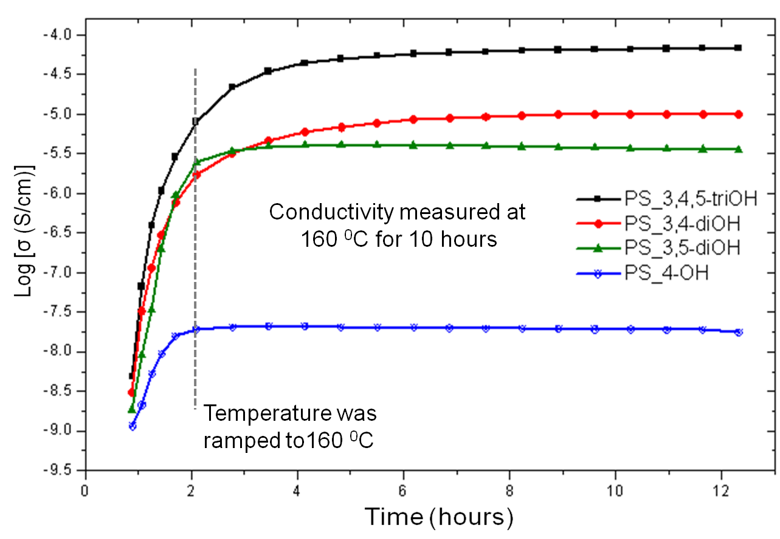
Figure S1. Proton conductivity of phenolic polymers (at 160 ⁰C) as a function of time

(ii) Membrane preparation for humidity measurements: A Teflon tape spacer with a hole of thickness 292 µm and an area of 0.0792 cm² was placed onto a Spectracarb 2050-A carbon gas diffusion electrode into which polymer films were drop cast from concentrated DMF solution and sandwiched with another gas diffusion electrode. These membrane electrode assemblies were prepared on a hot plate and were annealed at 100 ⁰C prior to measurements, then were clamped between two porous stainless steel disc electrodes (with 40 micron pores). This arrangement of electrodes was specifically designed to allow for considerable gas flow over the sample in order to speed equilibration during measurement. The samples were first analyzed via impedance spectroscopy while annealing for over 10 hours under vacuum up to 150 ⁰C, following similar protocol described above. Then, the assemblies were transferred to an ESPEC SH-241 temperature/humidity chamber and were exposed to 30% relative humidity at room temperature for 12 hours. Directly after humidifying, the temperature was ramped up to 150 ⁰C at a rate of 0.67 ⁰C/min and impedance spectra were measured approximately every half hour (roughly every 20 ⁰C).

(iii) Sample preparation for Pyrogallol: Pyrogallol was melted inside the glove box and filled into a custom electrode assembly consisting of two brass electrodes inserted into a segment of PTFE tubing - the sample is confined between the electrodes in a cylindrical volume of length 0.3870 cm and area 0.0792 cm². This material was analyzed at high temperatures in the melt state using impedance spectroscopy, following a similar procedure described above for measurements under vacuum; only a short range of temperatures could be investigated, since the sample crystallized while cooling below 130 ⁰C and has an immeasurably low conductivity in this state.

Activation energy (E_{a}) calculations. The activation energy is the minimum energy required for proton conduction through the polymer membrane. It was calculated using the Arrhenius equation (ln σ = ln σ_{o} – (E_{a}/RT)), where R is the universal gas constant and T is the temperature in Kelvin. The E_{a} was obtained from the slope of the linear fit of ln σ vs. 1/T. The pre-exponential factor (ln σ_{o}) was neglected.

Computational Methods. Density functional theory (LSDA)^{[1]} as implemented in Gaussian03 and Gaussian Development Version^{[2]} was used to compute structures, energies and frequencies. PS-4-OH dimer was formed by optimizing with LSDA/6-311G(d,p).^{[3]} The LSDA functional (level of theory) was used because it is known to capture π-π interactions with accuracy comparable to MP2.^{[4]} The 6-311G(d,p) basis set was used because of our previous calculations finding that this basis set captures hydrogen bonding and proton addition in organic and inorganic networks. The reoriented dimer structure was initialized by rotating the two OH groups in the PS-4-OH dimer to mimic the re-oriented structure; we then optimized this initial structure. The transition state between the two minima was found using the quadratic synchronous transit (QST2). Frequency calculations were performed for each optimization to confirm classifications as minima and saddle points. Pentamers and protonated pentamers (formed by adding an extra proton) of PS-4-OH, PS-3,5-di-OH, PS-3,4-di-OH, and PS-3,4,5-tri-OH were initialized with LSDA/6-311G(d,p) by fixing the first and last carbons of the backbone atoms to mimic a polymer system; we then optimized these initial structures.
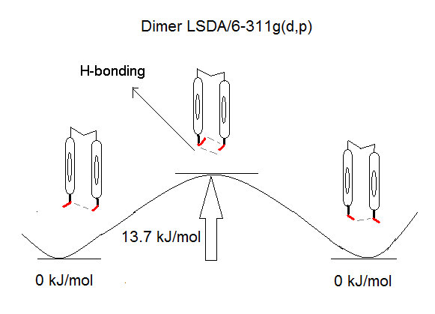
Figure S2. Structures of the PS-4-OH dimer and the transition state
Polymer Synthesis:

All the polymers were synthesized starting from the corresponding hydroxy benzaldehydes. The hydroxyl groups were first protected with t-butoxycarbonyl (Boc), following a reported procedure^{[5]} and the aldehyde was subsequently converted to a polymerizable double bond using Wittig reaction. The monomers were polymerized via free radical polymerization with AIBN as the initiator. The Boc groups were then deprotected using trifluoroacetic acid (TFA) to obtain the corresponding phenolic polymers.

Synthetic Scheme for PS-3,4,5-triOH Polymer.

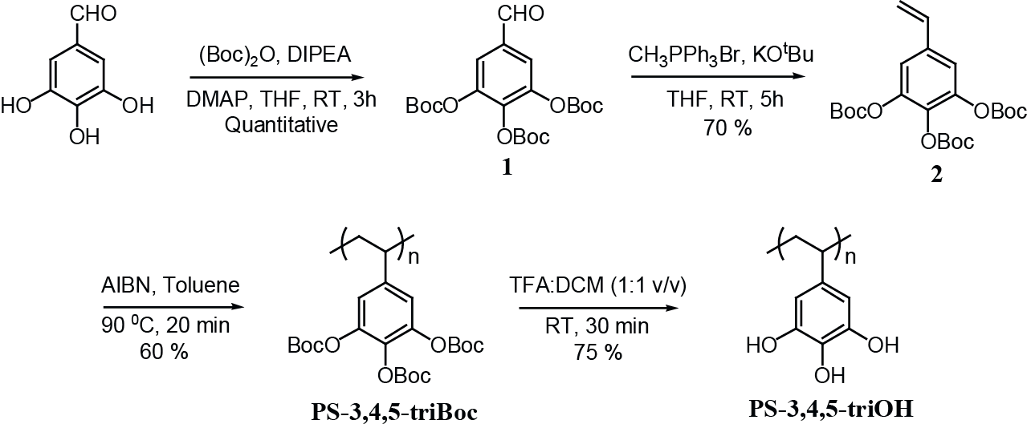

Synthesis of 3,4,5-tri(t-butoxycarbonyloxy) Benzaldehyde (1)
To a solution of 3,4,5-trihydroxy benzaldehyde (1.8 g, 10.5 mmol) in 70 mL THF was added N-N-diisopropylethylamine (DIPEA) (0.2 mL, 1.05 mmol), DMAP (64 mg, 0.53 mmol), and (Boc)₂O (10.1 mL, 47.05 mmol) at room temperature under argon. The reaction mixture was continued to stir at room temperature for 3 h. THF was evaporated and the crude was taken up in ethyl acetate and washed with 1M NaOH and saturated NaCl solutions. The combined ethyl acetate layers were dried over Na₂SO₄, concentrated under reduced pressure and the crude was purified by column chromatography (SiO₂). The product was eluted with ethyl acetate/hexane (15:85 v/v) to afford the desired product (4.7 g, 98%) as colorless oil. ¹H NMR (400 MHz, CDCl₃) δ: 9.91 (s, 1H), 7.70 (s, 2H), 1.53 (s, 27H). ¹³C NMR (100 MHz, CDCl₃) δ: 189.45, 150.08, 148.76, 144.66, 140.12, 133.75, 121.34, 84.93, 84.79, 27.65, 27.61.

Synthesis of 3,4,5-tri(t-butoxycarbonyloxy) Styrene (2)
MePPh₃Br (5.0 g, 13.94 mmol) and KO^{t}Bu (1.56 g, 13.94 mmol) were taken in a 100 mL oven-dried schlenk flask and dried under vacuum for 30 min. The flask was cooled to 0 ⁰C using ice bath and anhydrous THF (50 mL) was added under argon. The solution immediately turned yellow, indicating the formation of ylide. The reaction mixture was allowed to stir at 0 ⁰C for 30 min and was then warmed to room temperature. A solution of compound 1 (4.22 g, 9.3 mmol) in 20 mL THF was added using syringe and the reaction mixture was continued to stir at room temperature for 12 h. The reaction was quenched by the addition of water and extracted with ethyl acetate. The combined ethyl acetate layers were dried over Na₂SO₄, concentrated under reduced pressure and the crude was purified by column chromatography (SiO₂). The product was eluted with ethyl acetate/hexane (15:85 v/v) to afford the desired product (2.96 g, 70%) as colorless oil. ¹H NMR (400 MHz, CDCl₃) δ: 7.18 (s, 2H), 6.65-6.58 (dd, J = 17.6, 10.9 Hz,1H), 5.71-5.67 (d, J = 17.6 Hz, 1H), 5.30-5.28 (d, J = 10.9 Hz, 1H), 1.53 (s, 27H). ¹³C NMR (100 MHz, CDCl₃) δ: 150.36, 149.39, 143.78, 135.81, 134.86, 134.45, 117.85, 115.79, 84.00, 27.60, 27.56.

Synthesis of PS-3,4,5-triBoc Polymer
A solution of monomer 2 (2.5 g, 5.26 mmol) in 2.5 mL anhydrous toluene was taken in a 10 mL oven-dried schlenk flask under argon at room temperature. AIBN (9.1 mg, 0.06 mmol) was added and the reaction mixture was subjected to three freeze-pump-thaw cycles. It was stirred at room temperature for 5 min and transferred to an oil bath preheated to 90 ⁰C. The polymerization was carried out with an argon inlet and the outlet connected to an oil bubbler. The polymerization was complete within 20 min. The polymer was diluted with THF and precipitated twice into hexane. The precipitate was filtered, washed several times with hexane, and dried under vacuum at 50 ⁰C for 12 h to obtain the polymer (1.5 g, 60%) as white solid. GPC (THF) Mn: 60,000. PDI: 1.5. ¹H NMR (400 MHz, CDCl₃) δ: 6.49 (br, 2H, ArH), 1.74 (br, 1H, -CH of polymer backbone), 1.4 (s, 27H, O-C(CH₃)₃), 1.00 (br, 2H, -CH₂ of polymer backbone).

Synthesis of PS-3,4,5-triOH Polymer
PS-3,4,5-triBoc ( 1.4 g, 3.09 mmol) was taken in 5 mL DCM at room temperature under argon and 5 mL trifluoro acetic acid (TFA) was added to it. The clear solution obtained was stirred at room temperature for 30 min, during which the solution initially turned turbid and finally a white precipitate was obtained. The precipitate was filtered, washed thoroughly with DCM, and dried under vacuum at 50 ⁰C for 24 h. The polymer (353 mg, 75%) was obtained as light brown powder. ¹H NMR (400 MHz, DMSO-d6) δ: 8.8-7.2 (bd, 3H, -OH), 5.74 (bs, 2H, ArH), 2.2-0.5 (bd, 3H, -CH and -CH₂ of polymer backbone).

3,4-di(t-butoxycarbonyloxy) Benzaldehyde

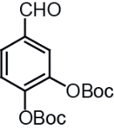
¹H NMR (400 MHz, CDCl₃) δ: 9.89 (s, 1H), 7.75 (d, J = 1.9 Hz, 1H), 7.73-7.70 (dd, J = 8.4, 1.9 Hz,1H), 7.40 (d, J = 8.4 Hz, 1H), 1.50 (s, 18H). ¹³C NMR (100 MHz, CDCl₃) δ: 190.06, 150.27, 149.83, 147.29, 143.19, 134.55, 128.02, 123.90, 123.74, 84.50, 84.33, 27.49.

3,5-di(t-butoxycarbonyloxy) Benzaldehyde

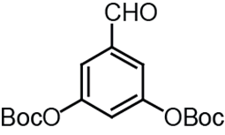
¹H NMR (400 MHz, CDCl₃) δ: 9.96 (s, 1H), 7.60 (d, J = 2.3 Hz, 2H), 7.33 (t, J = 2.3 Hz, 1H), 1.56 (s, 18H). ¹³C NMR (100 MHz, CDCl₃) δ: 190.19, 152.17, 151.06, 138.15, 120.75, 119.56, 84.65, 27.79.

3,4-di(t-butoxycarbonyloxy) Styrene

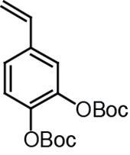
¹H NMR (400 MHz, CDCl₃) δ: 7.29-7.19 (m, 3H), 6.68-6.61 (dd, J = 17.8, 10.8 Hz, 1H), 5.71-5.67 (d, J = 17.8 Hz, 1H), 5.27-5.24 (d, J = 10.8 Hz, 1H), 1.55 (s, 9H), 1.54 (s, 9H). ¹³C NMR (100 MHz, CDCl₃) δ: 150.74, 150.71, 142.59, 141.96, 136.41, 135.29, 124.21, 123.04, 120.51, 114.98, 83.77, 27.63.

3,5-di(t-butoxycarbonyloxy) Styrene

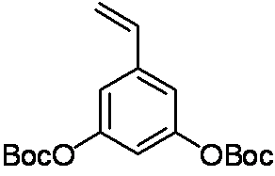
¹H NMR (400 MHz, CDCl₃) δ: 7.09-7.08 (d, J = 2.2 Hz, 2H), 6.98-6.97 (t, J = 2.2 Hz, 1H), 6.68-6.60 (dd, J = 17.6, 10.8 Hz, 1H), 5.76-5.71 (d, J = 17.6 Hz, 1H), 5.32-5.29 (d, J = 10.8 Hz, 1H), 1.55 (s, 18H). ¹³C NMR (100 MHz, CDCl₃) δ: 151.54, 151.31, 139.79, 135.34, 116.28, 115.90, 114.01, 83.81, 27.69.

3,4,5-trimethoxy Styrene

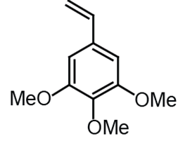
¹H NMR (400 MHz, CDCl₃) δ: 6.65-6.58 (dd, J = 17.6, 10.8 Hz, 1H and s, 2H, ArH), 5.66-5.62 (d, J = 17.6 Hz, 1H), 5.20-5.18 (d, J = 10.8 Hz, 1H), 3.85 (s, 6H), 3.82 (s, 3H). ¹³C NMR (100 MHz, CDCl₃) δ: 153.29, 137.97, 136.76, 133.32, 113.24, 103.25, 60.88, 56.04.

PS-3,4-diBoc Polymer

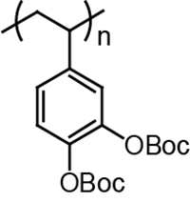
GPC (THF) Mn: 63,000; PDI: 1.6. ¹H NMR (400 MHz, CDCl₃) δ: 7.1-6.2 (bd, 3H, ArH), 1.73 (br, 1H, -CH of polymer backbone), 1.44 (s, 18H, O-C(CH₃)₃), 1.29 (br, 2H, -CH₂ of polymer backbone).

PS-3,5-diBoc Polymer

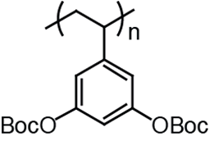
GPC (THF) Mn: 63,000; PDI: 1.4. ¹H NMR (400 MHz, CDCl₃) δ: 6.9-6.1 (bd, 3H, ArH), 1.87 (br, 1H, -CH of polymer backbone), 1.43 (s, 18H, O-C(CH₃)₃), 1.26 (br, 2H, -CH₂ of polymer backbone).

PS-3,4,5-triOMe Polymer

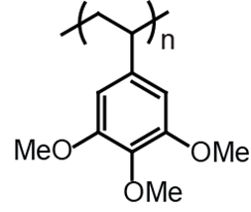
GPC (THF) Mn: 24,000; PDI; 1.34. ¹H NMR (400 MHz, CDCl₃) δ: 5.80-5.65 (br, 2H, ArH,), 3.69 (bs, 3H, -OMe), 3,53 (bs, 6H, -OMe) 1.81 (bs, 1H, -CH of polymer backbone), 1.41 (bs, 2H, -CH₂ of polymer backbone).

PS-3,4-diOH Polymer

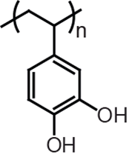
¹H NMR (400 MHz, DMSO-d6) δ: 8.36 (s, 2H, -OH), 6.7-5.5 (bm, 3H, ArH), 2.2-0.5 (bd, 3H, -CH and -CH₂ of polymer backbone).

PS-3,5-diOH Polymer

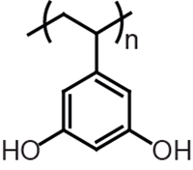
¹H NMR (400 MHz, DMSO-d6) δ: 8.69 (bs, 2H, -OH), 6.2-5.3 (bd, 3H, ArH), 2.2-0.5 (bd, 3H, -CH and -CH₂ of polymer backbone).

Details of Polymers

Polymer | Mn^{[a]} (g/mol) | PDI | Polymer | Mn^{[b]}  (g/mol) | T_{d,5%}^{[c]}  ( ⁰C) | T_{d,5%}^{[d]}  ( ⁰C) | T_{g}  ( ⁰C)
PS-3,4,5-triBoc | 60,000 | 1.5 | PS-3,4,5-triOH | 20,000 | 267 | 265 | 233
PS-3,4-diBoc | 63,000 | 1.6 | PS-3,4-diOH | 26,000 | 267 | 308 | 199
PS-3,5-diBoc | 64,000 | 1.4 | PS-3,5-diOH | 25,000 | 239 | 258 | 227
PS-4-Boc | NA | NA | PS-4-OH | 25,000 | 285 | 347 | 187

^{[a]} estimated by GPC (THF) using PS standards.
^{[b]} estimated based on the complete deprotection of Boc groups, which was confirmed by both ¹H NMR (Figure S4) and FT-IR (Figure S5). The molecular weights obtained from
GPC (DMF, 0.1 M LiCl, 50 ⁰C) were greater than 100 k for all the polymers. We suspect that the polymers might be aggregating due to the strong hydrogen bonding interactions between the hydroxyl groups.
^{[c]} Temperature at 5% weight loss when heated under air at 1 ⁰C/min
^{[d]} Temperature at 5% weight loss when heated under nitrogen at 10 ⁰C/min

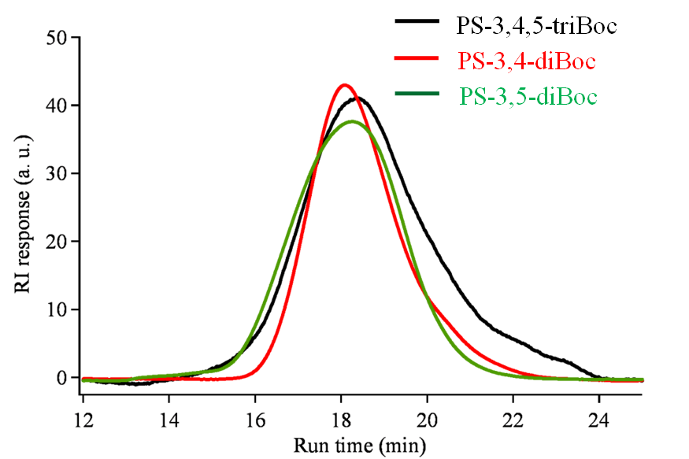

Figure S3. GPC traces of Boc protected phenolic polymers

a)
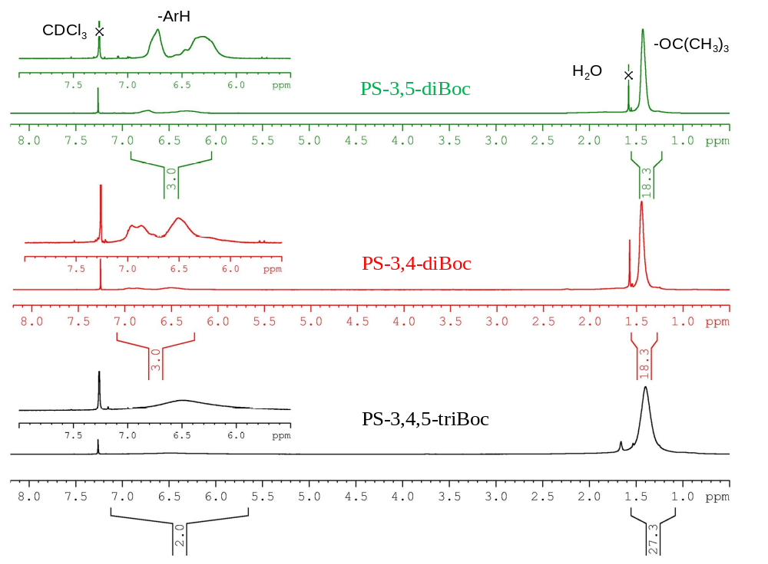
b)
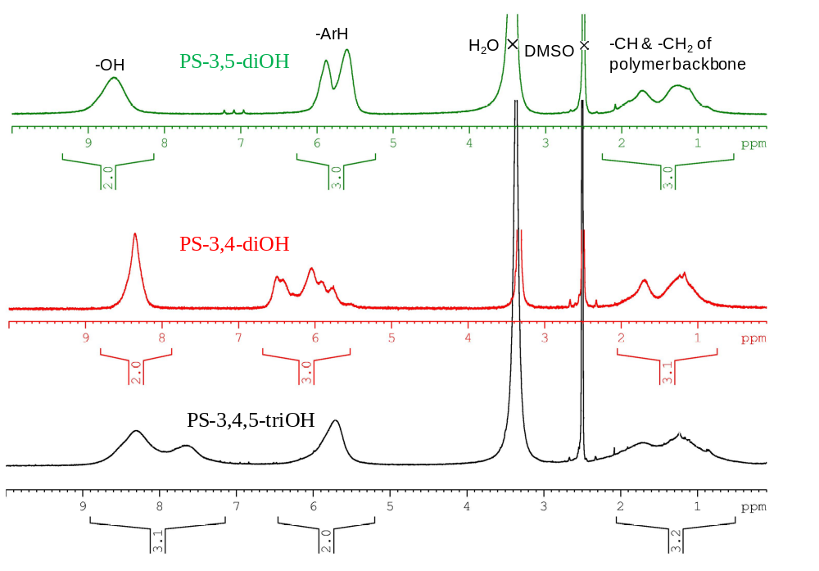

Figure S4. ¹H NMR spectra of a) Boc protected phenolic polymers; b) phenolic polymers
a)
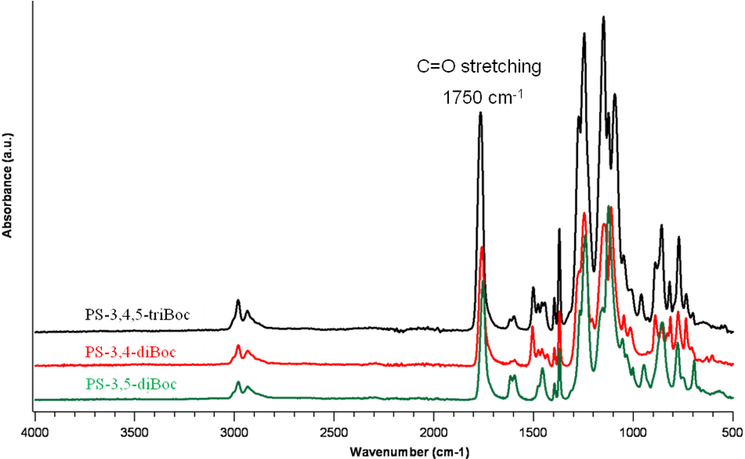
b)

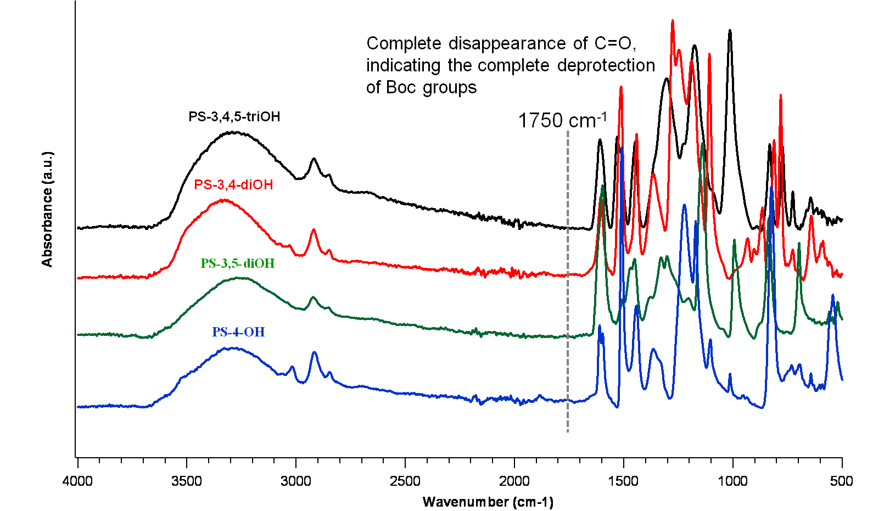

Figure S5. FT-IR spectra of a) Boc protected phenolic polymers; b) phenolic polymers

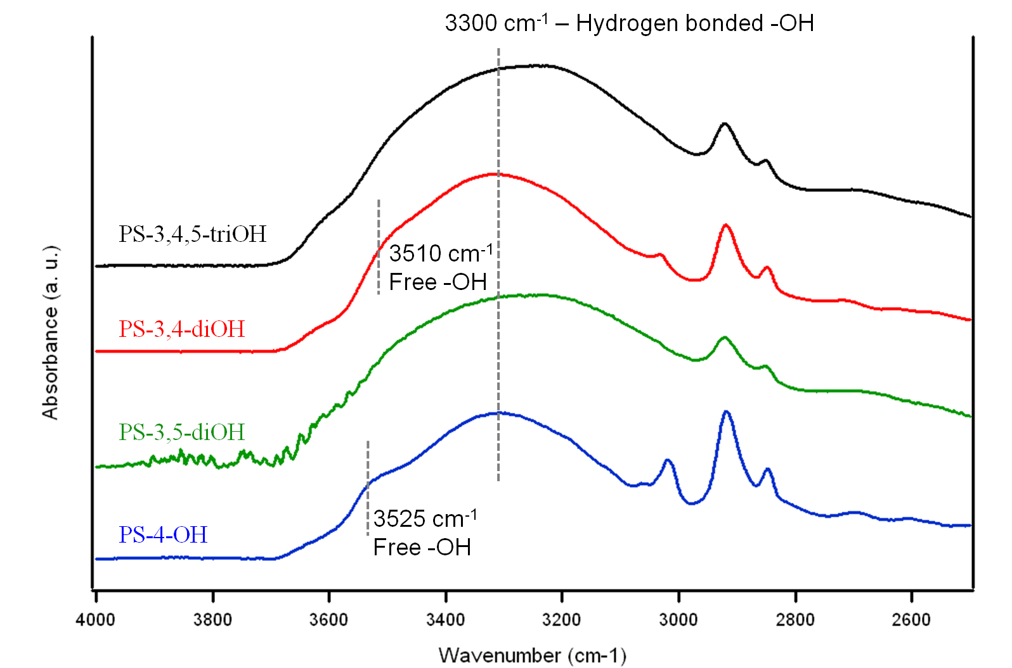

Figure S6. ATR-IR spectra of phenolic polymers (thin films)

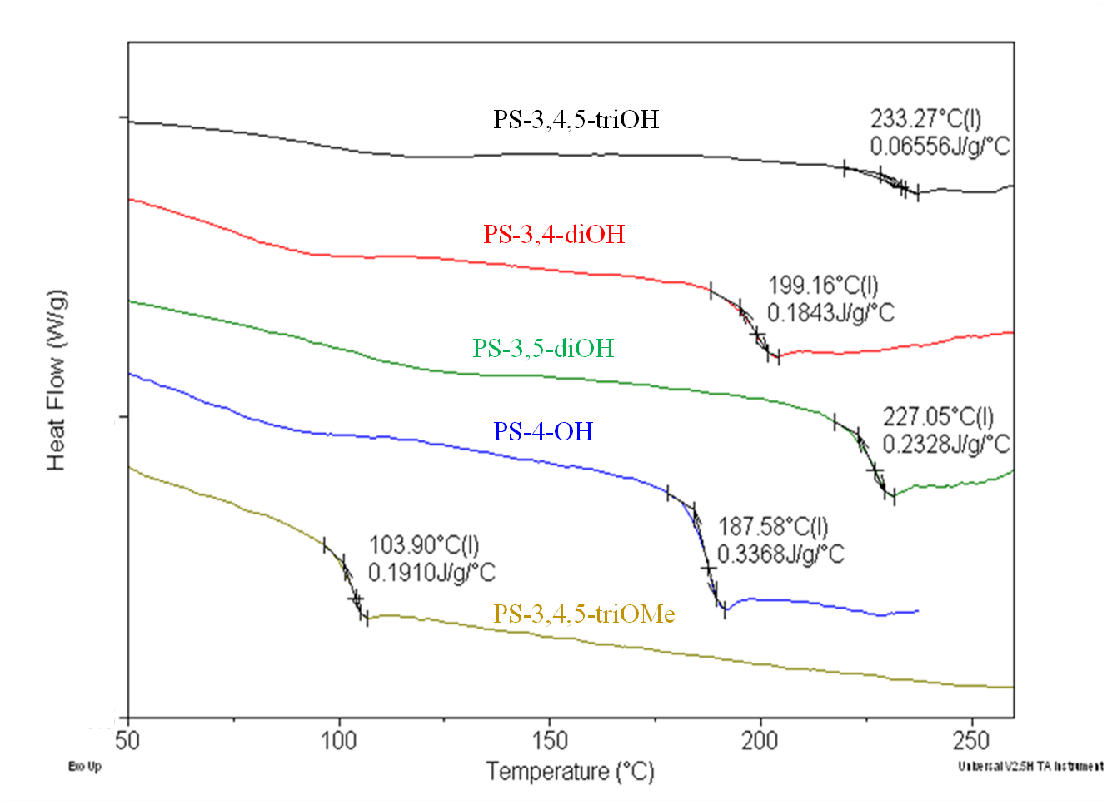
Figure S7. DSC traces of phenolic polymers

a)
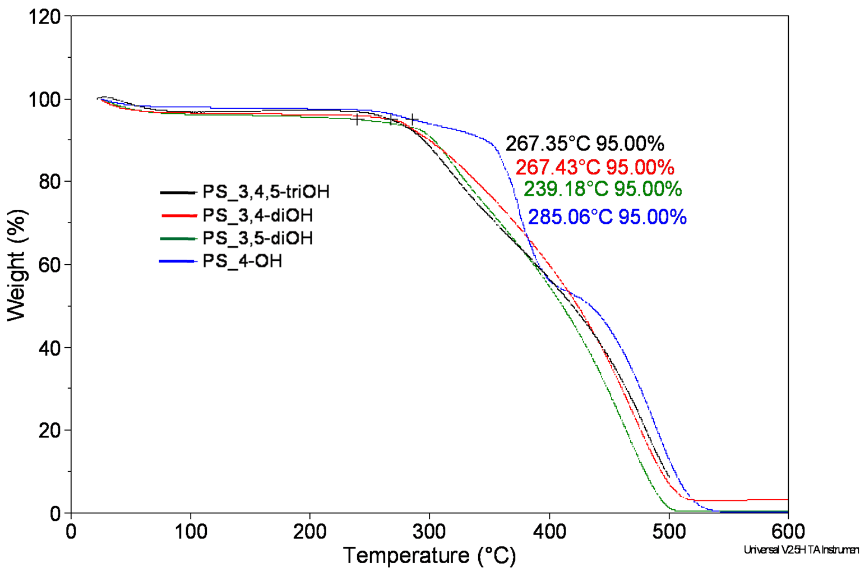
b)
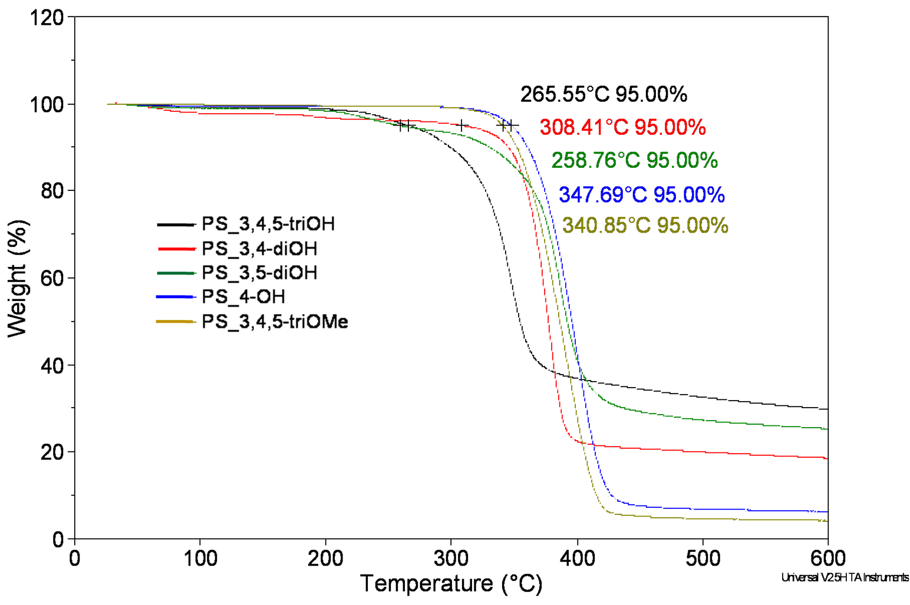

Figure S8. TGA traces of phenolic polymers a) when heated under air at 1 ⁰C/min; b) when heated under nitrogen at 10 ⁰C/min

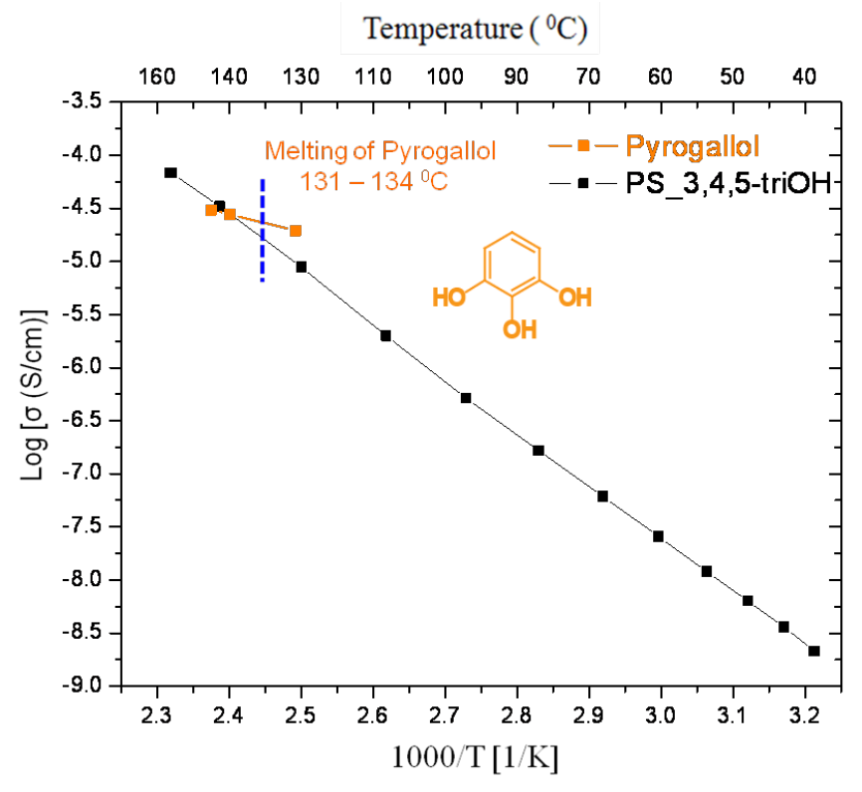
Figure S9. Proton conductivity of PS-3,4,5-triOH in comparison with the corresponding small molecule, pyrogallol

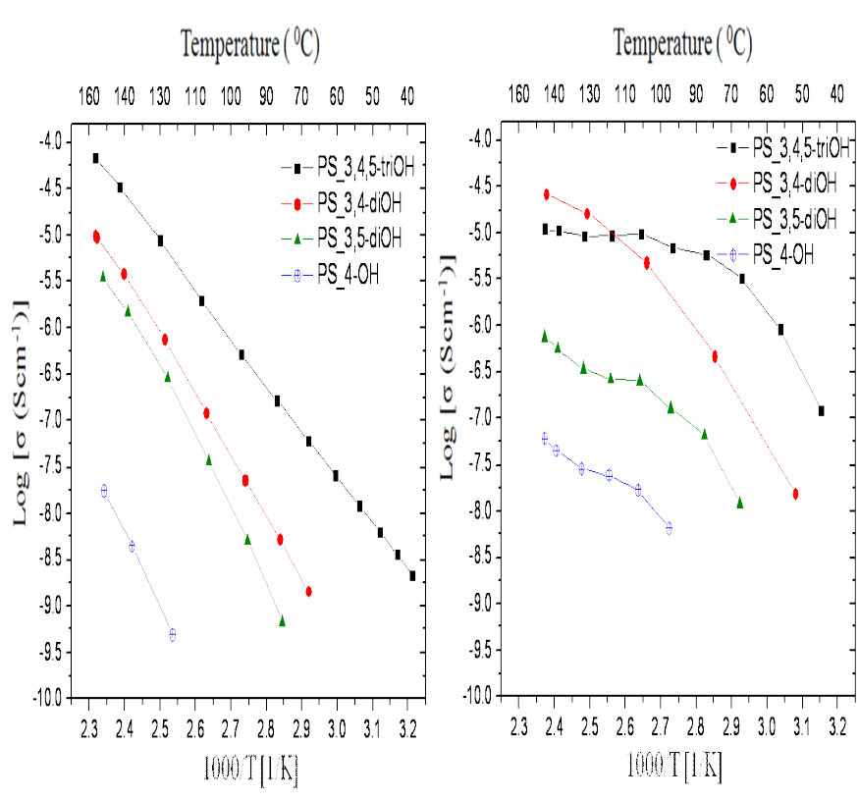
Figure S10. Proton conductivity of phenolic polymers with 30% relative humidity

References

1 M. J. Frisch, G. W. Trucks, H. B. Schlegel, G. E. Scuseria, M. A. Robb, J. R. Cheeseman, V. G. Zakrzewski, J. A. Montgomery Jr., R. E. Stratmann, J. C. Burant, S. Dapprich, J. M. Millam, A. D. Daniels, K. N. Kudin, M. C. Strain, O. Farkas, J. Tomasi, V. Barone, M. Cossi, R. Cammi, B. Mennucci, C. Pomelli, C. Adamo, S. Clifford, J. Ochterski, G. A. Petersson, P. Y. Ayala, Q. Cui, K. Morokuma, P. Salvador, J. J. Dannenberg, D. K. Malick, A. D. Rabuck, K. Raghavachari, J. B. Foresman, J. Cioslowski, J. V. Ortiz, A. G. Baboul, B. B. Stefanov, G. Liu, A. Liashenko, P. Piskorz, I. Komaromi, R. Gomperts, R. L. Martin, D. J. Fox, T. Keith, M. A. Al-Laham, C. Y. Peng, A. Nanayakkara, M. Challacombe, P. M. W. Gill, B. Johnson, W. Chen, M. W. Wong, J. L. Andres, C. Gonzalez, M. Head-Gordon, E. S. Replogle, J. A. Pople, Gaussian 98 (Gaussian, Inc., Pittsburgh, PA, 1998).
2 (a) P. Hohenberg, W. Kohn, Phys. Rev. 1964, 136, B864; (b) W. Kohn, L. J. Sham, Phys. Rev. 1965, 140, A1133; (c) J. C. Slater, The Self-Consistent Field for Molecular and Solids, Quantum Theory of Molecular and Solids, Vol. 4 (McGraw-Hill, New York, 1974); (d) S. H. Vosko, L. Wilk, M. Nusair, Can. J. Phys. 1980, 58, 1200.
3 (a) A. D. McLean, G. S. Chandler, J. Chem. Phys. 1980, 72, 5639; (b) K. Raghavachari, J. S. Binkley, R. Seeger, J. A. Pople, J. Chem. Phys. 1980, 72, 650.
4 M. Swart, T. Wijst, C. F. Guerra, F. M. Bickelhaupt, J. Mol. Model 2007, 13, 1245.
5 K. C. Nicolaou, T. Lister, R. M. Denton, C. F. Gelin, Tetrahedron 2008, 64, 4736.

